CGI(Common Gateway Interface)
- Each request forks a script as a new separate process
- Script receives headers and GET variables in environment (by communication btwn parent/child process)
- script reads POST body from standard input(using pipes).
- script writes response body to standard output(using pipes).

But this approach was inherently inefficient due to overhead in launching whole new process for every single request. To overcome these problems, couple of alternatives were introduced.

CGI script generally go in a webserver’s ../cgi-bin/ directory. CGI programming is writing dynamically generating WebPages that respond to user input or WebPages that interact with software on the http server.
Setup
- To be able to get our CGI to work we need a web server we can play with.
- If you have your own web server and want to use that go ahead.
- If you don’t then set up and apache2 web server on our Ubuntu box.
- To install Apache2 (which should be a standard package in almost all linux distro’s) we use: sudo apt-get install apache2
- Next, we must set up the web server permissions to allow cgi programs to execute, by modifying /etc/apache2/sites-available/000-default.conf file
DocumentRoot /var/www/
<Directory “/var/www”>
Options ExecCGI Indexes FollowSymLinks MultiViews
AllowOverride None
Order allow,deny
allow from all
AddHandler cgi-sccript .py
</Directory>
Read more:
http://httpd.apache.org/docs/current/mod/core.html#directory
http://httpd.apache.org/docs/current/mod/core.html#Options
http://httpd.apache.org/docs/current/mod/core.html#AllowOverride
- For simplicity, we will allow cgi to execute in the root directory, `/var/www/`
- Restart apache2, sudo service apache2 restart
- Let’s create a basic script that just prints out that it worked and print hello world 5 times
- Must have a line telling the webserver where python is installed(#!/usr/bin/python3.6)
#!/usr/bin/python3.6
# Hello.py
print(‘Content-type:text/html\r\n\r\n’)
print(‘<html><body>’)
print(‘<h1> It works! </h1>’)
for i in range(5):
print(‘<h2> Hello world! ’ + str(i) + ‘</h2>’)
print(‘</body></html>’)
- sudo chmod 755 hello.py
- cp ./hello.py /var/www/
- Enable cgi, sudo a2enmod cgi
- Restart apache2, sudo service apache2 restart and goto http://localhost/hello.py
- The cgi module contains a lot of declarations and does a lot of initializing in the background.
- Because of this Never use: from cgi import …
- cgi provides us with methods to get POST and GET requests from the web server.
- cgi also provides few other methods for parsing data.
- The python cgi module handles POST and GET with the same method.
- cgi.FieldStorage() method will return a FieldStorage object that allows us to get data from a submitted form.
- We can user the FieldStorage object like a python dictionary or we can use the getvalue() method. (I suggest not using this method as it will crash if there is more than one field with the same name. but for now it’s fine)
- Alternative methods are getfirst() and getlist() (Safe)
- let’s create a simple script that grabs the entered name from POST and prints out hello to that name. Let’s add a checkbox to see if they are happy or sad or both
#!/usr/bin/python3.6
import cgi
# Hello.py
print(‘Content-type:text/html\r\n\r\n’)
print(‘<html><body>’)
print(‘<h1> It works! </h1>’)
form = cgi.FieldStorage()
try:
name = form.getvalue(‘name’)
except AttributeError:
print(‘<h1>Sorry</h1>’)
print(“<h1>Hello ’+name+’! Thanks for using my script!</h1><br/>”)
if form.getvalue(‘happy’):
print(“<p> Yay! I’m happy too! </p>”)
if form.getvalue(‘sad’):
print(‘<p> Oh no! Why are you sad! </p>’)

print(“<form method=’post’ action=’Hello.py’>”)
print(“<p>Name: <input type=’text’ name=’name’/></p>”)
print(“<input type=’checkbox’ name=’happy’ /> Happy”)
print(“<input type=’checkbox’ name=’sad’ /> Sad”)
print(“<input type=’submit’ value=’Submit’ />”)
print(“</form>”)
print(‘</body></html>’)
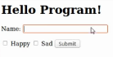
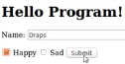
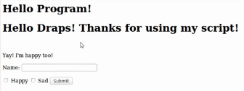

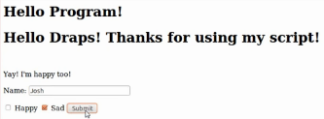
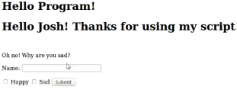

- When debugging code you can use the cgitb module to output errors to the page.
Import cgitb
cgitb.enable()
- The cgitb.enable() can be modified so that the error messages are saved to a file rather than output to users of your script. This can be done with:
cgitb.enable(display=0, logdir=“/path/”)
- cgi.escape() Try to always escape user input if you plan to use it!

